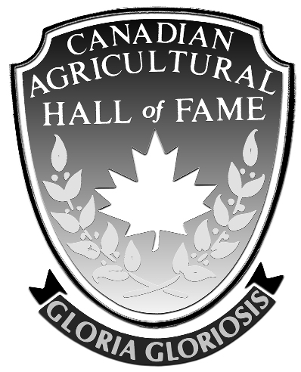

Canadian Agricultural Hall of Fame Association

Membership Form

As a member, you will be supporting the Canadian Agricultural Hall of Fame Association in celebrating and honouring Canadians for outstanding contributions to the agriculture and food industry and publicizing the importance of their achievements to Canada.

Full Name:

Title:

Association or Company Name (for Corporate Membership):

Full Address:

Telephone Number:

Email:

Member Classes

□ Individual Member $100 (lifetime)
□ Corporate Member $500 (one year)

Please make cheque payable to “Canadian Agricultural Hall of Fame Association” and mail with this completed form to:

Canadian Agricultural Hall of Fame
Doug McDonell, Secretary-Treasurer
9102 Fifth Line, RR 3
Georgetown, ON L7G 4S6
Phone: 905-878-4394 THANK YOU!!!

