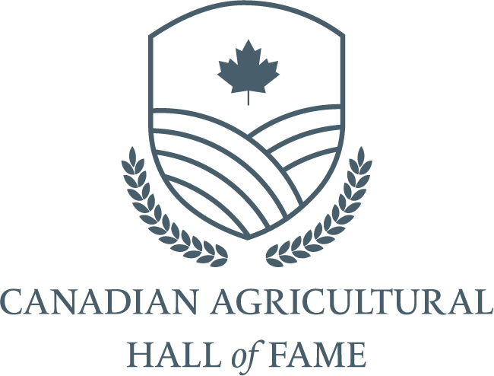

Nomination Instructions

Thank you for considering a nomination to the Canadian Agricultural Hall of Fame. The mission of the Canadian Agricultural Hall of Fame Association is to honour and celebrate Canadians for outstanding contributions to the agriculture and food industry, and to publicize the importance of their achievements to Canadians.

This nomination form will help guide you through the process. Please read carefully and complete with the utmost consideration for accuracy.

Candidates are selected for induction based on their career and volunteer contributions to Canadian agriculture. The review committee will look for demonstrated leadership, achievements, results, benefits and innovations accrued to agriculture on a Canadian or broader basis.

To be eligible for recognition:

- Candidates must have made significant contributions on a national or international basis (not just provincially).
- Candidates must have demonstrated a clear vision for the future of agriculture in Canada. Nominators must document this vision, outline successes towards achievement of this vision, and identify any obstacles that were overcome to achieve this vision.
- Candidates must have a lasting legacy for Canadian agriculture, with an impact that extends to the broader industry.

Guidelines

- Only individual persons are eligible for nomination. Posthumous nominations are accepted.
- Nominations must be made by Individual or Corporate members of the Canadian Agricultural Hall of Fame Association.
- Nominations must be received by May 1 to be considered in the current year.
- Nominators are encouraged to include a minimum of 3 and maximum of 10 letters of support.
- If the candidate has been selected for induction, nominators are required to cover the cost of a painted and framed portrait, which is $6000. Nominators shall supply photos of the nominee for the artist.
- Nominations are reviewed and selected by the Board of Directors of the Canadian Agricultural Hall of Fame Association.
- The Directors shall select the portrait artists to paint the nominees and arrange for framing.
- Submissions that do not follow these guidelines will be returned to the nominator and not considered for induction.
- All nominators will be contacted whether their candidate was successful or not. Please note that candidates can be re-nominated each year for a maximum of three years.

Nominations should be submitted in hard copy to:

Canadian Agricultural Hall of Fame
Brenda Trask, Executive Director
Box 576, 3268C Old George Street
Osgoode, ON K0A 2W0
Phone: 613-720-7528

A supplemental electronic copy can be emailed to execdirector@cahfa.com

Nomination Form

Name of Nominee:

Nominated by:

_________________________________________________________________________________________________

Signature of Nominator(s):

________________________________________________________________________________________

________________________________________________________________________________________

Nominator Information

Nominations must be made by Individual or Corporate members of the Canadian Agricultural Hall of Fame Association. The individual, group of individuals or organization(s) submitting the nomination is responsible for the portrait and framing cost of $6,000 if the nominee is selected for induction.

Nominator(s):  Name and organization / title if applicable | Contact Information:  Address, phone number, email

I/we, the undersigned, believe the information provided in this nomination form to be complete and accurate.

Signature of the Nominator/Nominating Organization:

______________________________________________________________________

______________________________________________________________________

This application shall be the property of the Canadian Agricultural Hall of Fame Association.

Nominee Information

Complete the table below. Please include as much detail as available.

Surname of Nominee
Given Name(s)
Year of Birth
Country of Birth
City/Region Where Born
Year of Death (if applicable)
Name of Spouse (if applicable)

Canadian Province of Residence
Current Address of Nominee (if applicable) or Family Member to be Contacted
Telephone
Email
Education – Secondary, name of school(s) attended
Education – College or University name of school(s) attended and degrees completed
List the geographical area(s) in Canada where lifetime work was accomplished

About the Nominee

Provide factual and chronological brief statements for each section below.

- Contribution to Canadian Agriculture

List the achievements, results, benefits and innovations accrued to Canadian agriculture as a result of the nominee’s career and leadership.

Consider: How did the nominee’s initiative and leadership lead to significant developments?
What impact did these achievements have in Canada? What was the benefit?
Was the nominee innovative or creative in an approach to an agriculture problem?
Why is the nominee’s contribution unique?

- Lasting Legacy

Identify the nominee’s lasting legacy to agriculture in Canada.

- Nominee’s Education/Certificates/Honours/Awards

What awards or recognition has the nominee received? List in chronological order.

- Nominee’s Involvement in Organizations and Leadership Achievements

Chronological list of offices held, years of service, and outstanding contributions.

- Nominee’s Volunteer Activities

How has the nominee volunteered time and talent to causes connected to agriculture?

- Other Comments or Supplemental Information

Attach letters of support (minimum 3 and maximum 10) that include knowledge of specific/outstanding accomplishments.

